For URL: <https://enough-kingfish.dataos.app/>

Modification

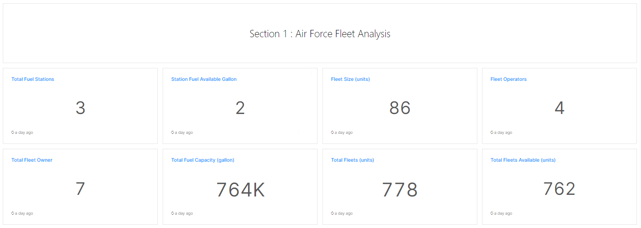

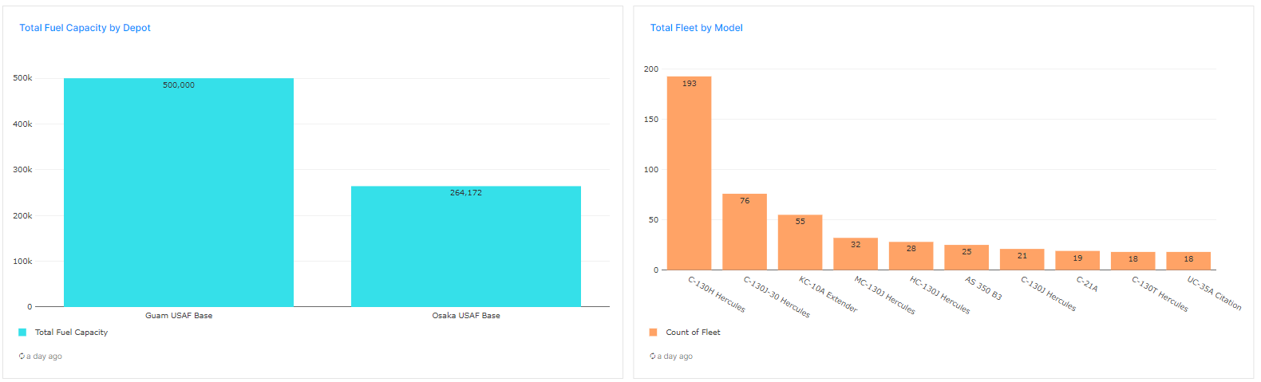

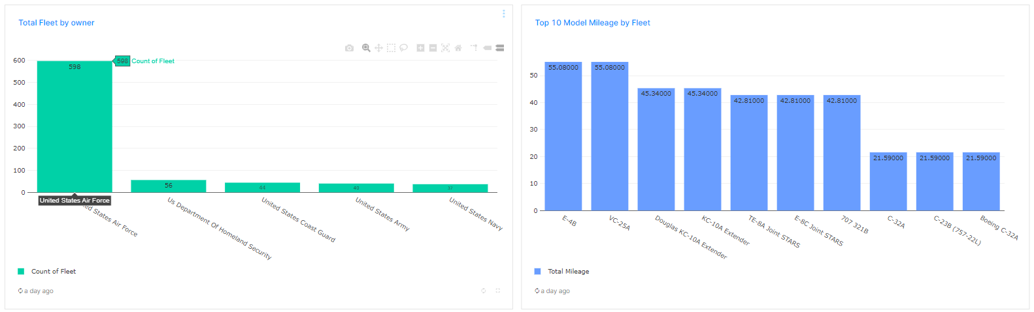

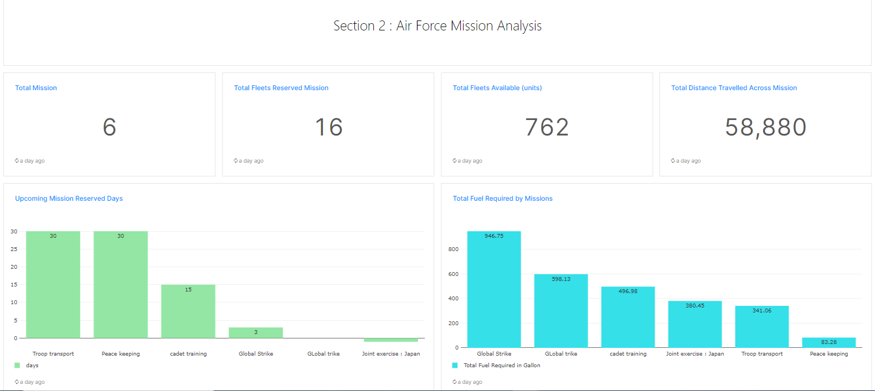

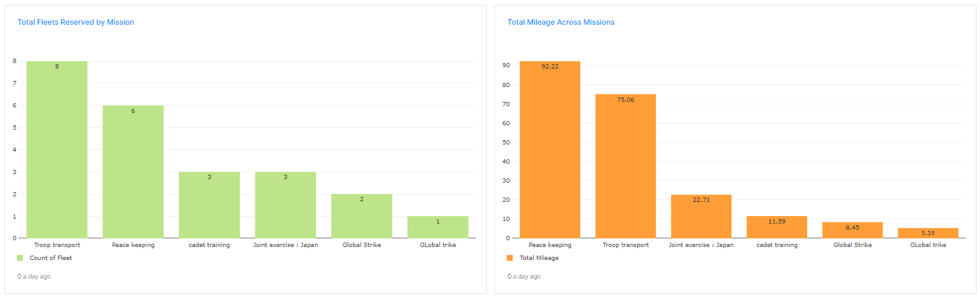

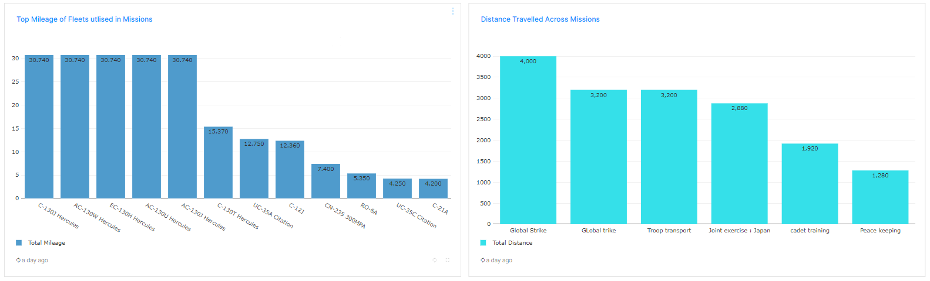

SQL Query:

* Total Fuel Stations

WITH t1 AS (

SELECT

idaoc,

name,

description,

city,

country,

split (depots, ',') AS depots

FROM (

SELECT

idaoc,

name,

description,

city,

country,

listagg (depots, ',') WITHIN GROUP (ORDER BY idaoc) AS depots

FROM

"icebase"."mitreusaf".usaf_aoc GROUP BY

1,

2,

3,

4,

5)),

t2 (idaoc, name, description, city, country, depot_id)

AS (

SELECT

idaoc,

name,

description,

city,

country,

t.*

FROM

t1

CROSS JOIN unnest(depots) AS t

)

SELECT

count(distinct depot_id) as total_depot

FROM

T2

### Station Fuel Available Gallon

SELECT

count(DISTINCT depotid) as total_depot

FROM

"icebase"."mitreusaf".usaf_depot

### Fleet Size (units)

SELECT count(distinct model) as total_model FROM "icebase"."mitreusaf".usaf_fleet where cast(milage as double) > 0

### Fleet Operators

SELECT count(distinct operator) as total_operator FROM "icebase"."mitreusaf".usaf_fleet where cast(milage as double) > 0

### Total Fleet Owner

SELECT count(distinct owner) as total_owner FROM "icebase"."mitreusaf".usaf_fleet where cast(milage as double) > 0

### Total Fuel Capacity (gallon)

SELECT

format_number (sum(Fuel_In_Gallons)) AS total_fuel_capacity

FROM ( SELECT DISTINCT

Fuel_In_Gallons

FROM (

SELECT

CASE WHEN unit = 'litres' THEN

cast(capacity / 3.785411784 AS decimal(10, 2))

WHEN unit = 'barrel' THEN

cast(capacity / 42 AS decimal(10, 2))

ELSE

capacity

END Fuel_In_Gallons

FROM

"icebase"."mitreusaf".usaf_depot))

### Total Fleets (units)

SELECT count(distinct icao24) as total_fleets FROM "icebase"."mitreusaf".usaf_fleet where cast(milage as double) > 0

### Total Fleets Available (units)

WITH t1 AS (

WITH t1 AS (

SELECT

missionid,

missionname,

total_distance,

start_date,

end_date,

createdat,

updatedat,

status,

depots,

aoc,

split (fleets, ',') AS fleet_id

FROM (

SELECT

missionname,

missionid,

total_distance,

start_date,

end_date,

createdat,

updatedat,

status,

depots,

aoc,

listagg (fleet, ',') WITHIN GROUP (ORDER BY missionid) AS fleets

FROM

"icebase"."mitreusaf".usaf_mission GROUP BY

1,

2,

3,

4,

5,

6,

7,

8,

9,

10)),

t2 (missionid, missionname, total_distance, start_date, end_date, createdat, updatedat, status, depots, aoc, fleet)

AS (

SELECT

missionid,

missionname,

total_distance,

start_date,

end_date,

createdat,

updatedat,

status,

depots,

aoc,

t.*

FROM

t1

CROSS JOIN unnest(fleet_id) AS t

)

SELECT

*

FROM

t2

),

t2 AS (

SELECT

icao24,

model,

milage

FROM

"icebase"."mitreusaf".usaf_fleet where cast(milage as double) > 0

),

t3 AS (

SELECT

count(DISTINCT fleet) AS total_mission_fleet,

count(DISTINCT icao24) AS total_fleet

FROM

t1

RIGHT JOIN t2 ON t1.fleet = t2.icao24

)

SELECT

total_fleet - total_mission_fleet AS total_fleet_available

FROM

t3

### Total Fuel Capacity by Depot

SELECT

depotname,

round(Fuel_In_Gallons ,0)AS total_fuel_capacity

FROM ( SELECT DISTINCT

depotname,

Fuel_In_Gallons

FROM (

SELECT

depotname,

CASE WHEN unit = 'litres' THEN

cast(capacity / 3.785411784 AS decimal(10, 2))

WHEN unit = 'barrel' THEN

cast(capacity / 42 AS decimal(10, 2))

ELSE

capacity

END Fuel_In_Gallons

FROM

"icebase"."mitreusaf".usaf_depot))

order by 2 desc

### Total Fleet by Model

SELECT

model,

count(DISTINCT icao24) AS total_fleet

FROM

"icebase"."mitreusaf".usaf_fleet

WHERE

cast(milage AS double) > 0

group by 1

order by 2 desc limit 10

### Total Fleet by owner

SELECT

owner,

count(DISTINCT icao24) AS total_fleet

FROM

"icebase"."mitreusaf".usaf_fleet

WHERE

cast(milage AS double) > 0

group by 1

order by 2 desc limit 5

### Top 10 Model Mileage by Fleet

SELECT

distinct

model,

round(cast(milage AS double),2) as milage

FROM

"icebase"."mitreusaf".usaf_fleet

WHERE

cast(milage AS double) > 0

order by 2 desc

limit 10

Section 2 : Air Force Mission Analysis

### Total Mission

SELECT

count(distinct missionid) as total_mision

FROM

icebase.mitreusaf.usaf_mission

### Total Fleets Reserved Mission

WITH t1 AS (

SELECT

missionid,

missionname,

total_distance,

start_date,

end_date,

createdat,

updatedat,

status,

depots,

aoc,

split (fleets, ',') AS fleet_id

FROM (

SELECT

missionname,

missionid,

total_distance,

start_date,

end_date,

createdat,

updatedat,

status,

depots,

aoc,

listagg (fleet, ',') WITHIN GROUP (ORDER BY missionid) AS fleets

FROM

"icebase"."mitreusaf".usaf_mission GROUP BY

1,

2,

3,

4,

5,

6,

7,

8,

9,

10)

),

t2 (

missionid, missionname, total_distance, start_date, end_date, createdat, updatedat, status, depots, aoc, fleet

) AS (

SELECT

missionid,

missionname,

total_distance,

start_date,

end_date,

createdat,

updatedat,

status,

depots,

aoc,

t.*

FROM

t1

CROSS JOIN unnest(fleet_id) AS t

)

SELECT

count(distinct fleet) as total_fleet

FROM

t2

### Total Fleets Available (units)

WITH t1 AS (

WITH t1 AS (

SELECT

missionid,

missionname,

total_distance,

start_date,

end_date,

createdat,

updatedat,

status,

depots,

aoc,

split (fleets, ',') AS fleet_id

FROM (

SELECT

missionname,

missionid,

total_distance,

start_date,

end_date,

createdat,

updatedat,

status,

depots,

aoc,

listagg (fleet, ',') WITHIN GROUP (ORDER BY missionid) AS fleets

FROM

"icebase"."mitreusaf".usaf_mission GROUP BY

1,

2,

3,

4,

5,

6,

7,

8,

9,

10)),

t2 (missionid, missionname, total_distance, start_date, end_date, createdat, updatedat, status, depots, aoc, fleet)

AS (

SELECT

missionid,

missionname,

total_distance,

start_date,

end_date,

createdat,

updatedat,

status,

depots,

aoc,

t.*

FROM

t1

CROSS JOIN unnest(fleet_id) AS t

)

SELECT

*

FROM

t2

),

t2 AS (

SELECT

icao24,

model,

milage

FROM

"icebase"."mitreusaf".usaf_fleet where cast(milage as double) > 0

),

t3 AS (

SELECT

count(DISTINCT fleet) AS total_mission_fleet,

count(DISTINCT icao24) AS total_fleet

FROM

t1

RIGHT JOIN t2 ON t1.fleet = t2.icao24

)

SELECT

total_fleet - total_mission_fleet AS total_fleet_available

FROM

t3

### Total Distance Traveled Across Mission

WITH t1 AS (

SELECT

missionid,

missionname,

total_distance,

start_date,

end_date,

createdat,

updatedat,

status,

depots,

aoc,

split (fleets, ',') AS fleet_id

FROM (

SELECT

missionname,

missionid,

total_distance,

start_date,

end_date,

createdat,

updatedat,

status,

depots,

aoc,

listagg (fleet, ',') WITHIN GROUP (ORDER BY missionid) AS fleets

FROM

"icebase"."mitreusaf".usaf_mission GROUP BY

1,

2,

3,

4,

5,

6,

7,

8,

9,

10)

),

t2 (

missionid, missionname, total_distance, start_date, end_date, createdat, updatedat, status, depots, aoc, fleet

) AS (

SELECT

missionid,

missionname,

total_distance,

start_date,

end_date,

createdat,

updatedat,

status,

depots,

aoc,

t.*

FROM

t1

CROSS JOIN unnest(fleet_id) AS t

)

SELECT

sum(total_distance) as total_distance

FROM

t2

### Upcoming Mission Reserved Days

WITH t1 AS (

WITH t1 AS (

SELECT

missionid,

missionname,

total_distance,

start_date,

end_date,

createdat,

updatedat,

status,

depots,

aoc,

split (fleets, ',') AS fleet_id

FROM (

SELECT

missionname,

missionid,

total_distance,

start_date,

end_date,

createdat,

updatedat,

status,

depots,

aoc,

listagg (fleet, ',') WITHIN GROUP (ORDER BY missionid) AS fleets

FROM

"icebase"."mitreusaf".usaf_mission GROUP BY

1,

2,

3,

4,

5,

6,

7,

8,

9,

10)),

t2 (missionid, missionname, total_distance, start_date, end_date, createdat, updatedat, status, depots, aoc, fleet)

AS (

SELECT

missionid,

missionname,

total_distance,

start_date,

end_date,

createdat,

updatedat,

status,

depots,

aoc,

t.*

FROM

t1

CROSS JOIN unnest(fleet_id) AS t

)

SELECT

*

FROM

t2

)

SELECT

distinct

missionname,

date_diff('day',start_date,end_date) as days

FROM

t1

order by 2 desc

### Total Fuel Required by Missions

WITH t1 AS (

WITH t1 AS (

SELECT

missionid,

missionname,

total_distance,

start_date,

end_date,

createdat,

updatedat,

status,

depots,

aoc,

split (fleets, ',') AS fleet_id

FROM (

SELECT

missionname,

missionid,

total_distance,

start_date,

end_date,

createdat,

updatedat,

status,

depots,

aoc,

listagg (fleet, ',') WITHIN GROUP (ORDER BY missionid) AS fleets

FROM

"icebase"."mitreusaf".usaf_mission GROUP BY

1,

2,

3,

4,

5,

6,

7,

8,

9,

10)),

t2 (missionid, missionname, total_distance, start_date, end_date, createdat, updatedat, status, depots, aoc, fleet)

AS (

SELECT

missionid,

missionname,

total_distance,

start_date,

end_date,

createdat,

updatedat,

status,

depots,

aoc,

t.*

FROM

t1

CROSS JOIN unnest(fleet_id) AS t

)

SELECT

*

FROM

t2

),

t2 AS (

SELECT

icao24,

manufacturername,

model,

OPERATOR,

OWNER,

milage

FROM

"icebase"."mitreusaf".usaf_fleet

),

t3 AS (

SELECT

missionname,

sum(total_distance) AS total_distances,

sum(round(cast(milage AS double), 2)) AS total_mileage

FROM

t1

JOIN t2 ON t1.fleet = t2.icao24

group by 1

)

SELECT

missionname,

total_distances / total_mileage as total_fuel_required

FROM

t3

order by 2 desc

### Total Fleets Reserved by Mission

WITH t1 AS (

WITH t1 AS (

SELECT

missionid,

missionname,

total_distance,

start_date,

end_date,

createdat,

updatedat,

status,

depots,

aoc,

split (fleets, ',') AS fleet_id

FROM (

SELECT

missionname,

missionid,

total_distance,

start_date,

end_date,

createdat,

updatedat,

status,

depots,

aoc,

listagg (fleet, ',') WITHIN GROUP (ORDER BY missionid) AS fleets

FROM

"icebase"."mitreusaf".usaf_mission GROUP BY

1,

2,

3,

4,

5,

6,

7,

8,

9,

10)),

t2 (missionid, missionname, total_distance, start_date, end_date, createdat, updatedat, status, depots, aoc, fleet)

AS (

SELECT

missionid,

missionname,

total_distance,

start_date,

end_date,

createdat,

updatedat,

status,

depots,

aoc,

t.*

FROM

t1

CROSS JOIN unnest(fleet_id) AS t

)

SELECT

*

FROM

t2

)

SELECT

missionname,

count(fleet) AS fleet

FROM

t1

GROUP BY

1

ORDER BY

2 DESC

### Total Mileage Across Missions

WITH t1 AS (

WITH t1 AS (

SELECT

missionid,

missionname,

total_distance,

start_date,

end_date,

createdat,

updatedat,

status,

depots,

aoc,

split (fleets, ',') AS fleet_id

FROM (

SELECT

missionname,

missionid,

total_distance,

start_date,

end_date,

createdat,

updatedat,

status,

depots,

aoc,

listagg (fleet, ',') WITHIN GROUP (ORDER BY missionid) AS fleets

FROM

"icebase"."mitreusaf".usaf_mission GROUP BY

1,

2,

3,

4,

5,

6,

7,

8,

9,

10)),

t2 (missionid, missionname, total_distance, start_date, end_date, createdat, updatedat, status, depots, aoc, fleet)

AS (

SELECT

missionid,

missionname,

total_distance,

start_date,

end_date,

createdat,

updatedat,

status,

depots,

aoc,

t.*

FROM

t1

CROSS JOIN unnest(fleet_id) AS t

)

SELECT

*

FROM

t2

),

t2 AS (

SELECT

icao24,

manufacturername,

model,

OPERATOR,

OWNER,

milage

FROM

"icebase"."mitreusaf".usaf_fleet

),

t3 AS (

SELECT

missionname,

sum(round(cast(milage AS double), 2)) AS total_mileage

FROM

t1

JOIN t2 ON t1.fleet = t2.icao24

group by 1

) select * from t3 order by 2 desc

### Top Mileage of Fleets utilized in Missions

WITH t1 AS (

WITH t1 AS (

SELECT

missionid,

missionname,

total_distance,

start_date,

end_date,

createdat,

updatedat,

status,

depots,

aoc,

split (fleets, ',') AS fleet_id

FROM (

SELECT

missionname,

missionid,

total_distance,

start_date,

end_date,

createdat,

updatedat,

status,

depots,

aoc,

listagg (fleet, ',') WITHIN GROUP (ORDER BY missionid) AS fleets

FROM

"icebase"."mitreusaf".usaf_mission GROUP BY

1,

2,

3,

4,

5,

6,

7,

8,

9,

10)),

t2 (missionid, missionname, total_distance, start_date, end_date, createdat, updatedat, status, depots, aoc, fleet)

AS (

SELECT

missionid,

missionname,

total_distance,

start_date,

end_date,

createdat,

updatedat,

status,

depots,

aoc,

t.*

FROM

t1

CROSS JOIN unnest(fleet_id) AS t

)

SELECT

*

FROM

t2

),

t2 AS (

SELECT

icao24,

manufacturername,

model,

OPERATOR,

OWNER,

milage

FROM

"icebase"."mitreusaf".usaf_fleet

),

t3 AS (

SELECT

model,

sum(round(cast(milage AS double), 2)) AS total_mileage

FROM

t1

JOIN t2 ON t1.fleet = t2.icao24

group by 1

) select * from t3 order by 2 desc

### Distance Traveled Across Missions

WITH t1 AS (

WITH t1 AS (

SELECT

missionid,

missionname,

total_distance,

start_date,

end_date,

createdat,

updatedat,

status,

depots,

aoc,

split (fleets, ',') AS fleet_id

FROM (

SELECT

missionname,

missionid,

total_distance,

start_date,

end_date,

createdat,

updatedat,

status,

depots,

aoc,

listagg (fleet, ',') WITHIN GROUP (ORDER BY missionid) AS fleets

FROM

"icebase"."mitreusaf".usaf_mission GROUP BY

1,

2,

3,

4,

5,

6,

7,

8,

9,

10)),

t2 (missionid, missionname, total_distance, start_date, end_date, createdat, updatedat, status, depots, aoc, fleet)

AS (

SELECT

missionid,

missionname,

total_distance,

start_date,

end_date,

createdat,

updatedat,

status,

depots,

aoc,

t.*

FROM

t1

CROSS JOIN unnest(fleet_id) AS t

)

SELECT

*

FROM

t2

)

SELECT

distinct

missionname,

total_distance

FROM

t1

order by 2 desc